TASK 12
PFAI LAB
Kaif Ikhlaq
BSAIM-S24-027
HadithBot
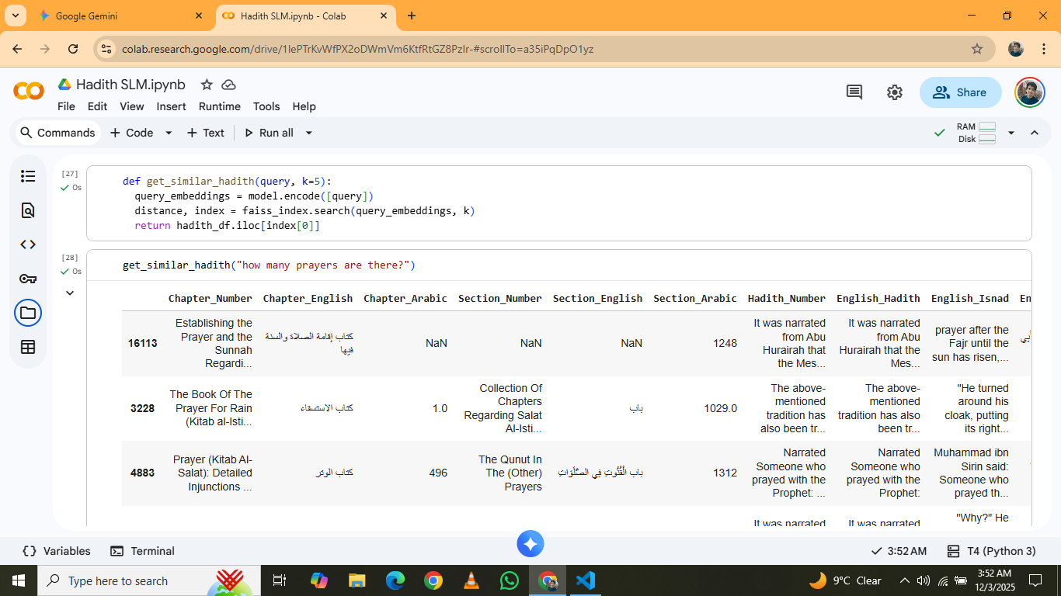

MindMatch Bot
• Core System: A retrieval-based AI using MiniLM and FAISS to semantically match user queries with verified mental health answers, avoiding generative hallucinations.
• Safety Mechanisms: Includes a Crisis Filter to detect emergencies immediately and a Confidence Threshold to block irrelevant or low-quality matches.
• Technical Pipeline: Implements a high-efficiency Vector Search architecture that converts text to embeddings for millisecond-level retrieval accuracy.
• Interface: Deployed as a Flask web application featuring a modern, responsive Glassmorphism UI designed for a calming user experience.
